Name | : | Yong Wern Jie |  | Marks:  /100
Matric No. | : | A22EC0121
Name | : | Tan Jun Yuan
Matric No. | : | A22EC0107
Section-Group | : | 02-3A
Link of video (Part 1) | : | https://youtu.be/sH38rQlQMCw

Instruction PART 2:

Printscreen the answer from the Wireshark and indicate the answer part by using the red dotted-line box, and write the answer in the blue dialog box. An example is given in Step1(b) (delete the printscreen before start).

- Edit the blue dialog box by right clicking and select ‘edit text’.
- Adjust the size of the red dotted-line and the dialog box according to your answer.
- Duplicate the group of shape (red dotted-line and the dialog box) for each answer.
- Make sure remain the original width of the table provided.

Once completed, convert this answer sheet into pdf format and save as <section>-<group>.pdf.
Example: 01-3A.pdf, 07-7B.pdf

PART 2: Examine Functionality of the TCP and UDP Protocols
Step1  [15m] | a) | 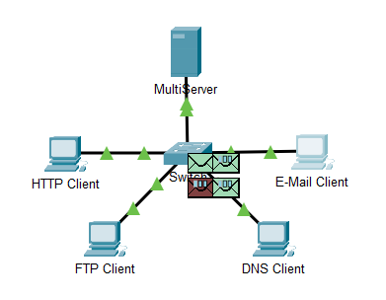  All PDUs are transferred to the switch  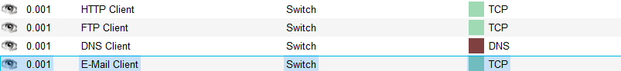
 | b) | 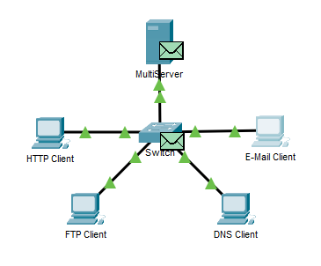  The PDUs that disappear have been stored in the switch.  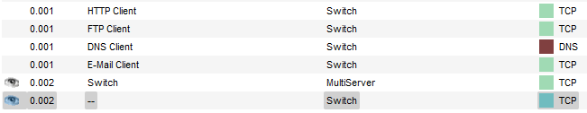

 | c) | First time:  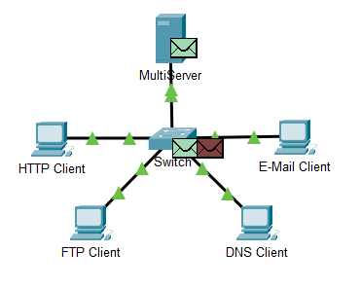  Multiplexing  Second time:  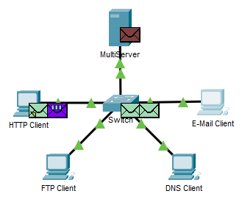  Multiplexing  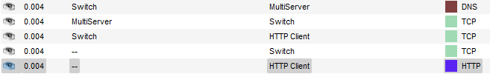  Third time:  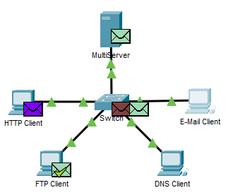  Multiplexing  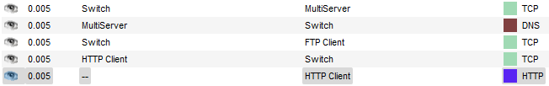  Fourth time:  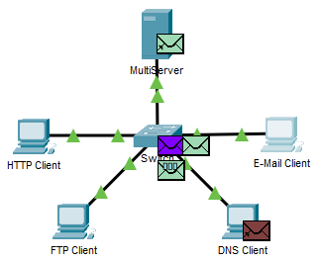  Multiplexing  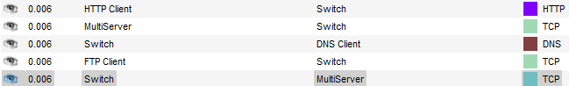  Fifth time:  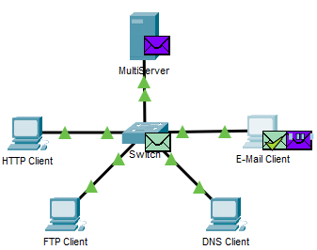  Multiplexing  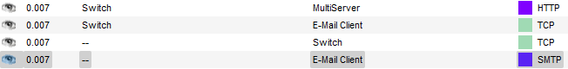  Sixth time:  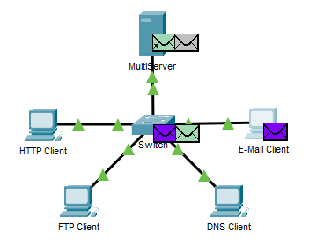  Multiplexing  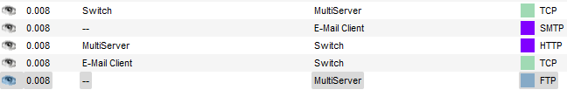
 | d) | 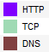  Different color represent different protocol
Step2  [15m] | c1) | 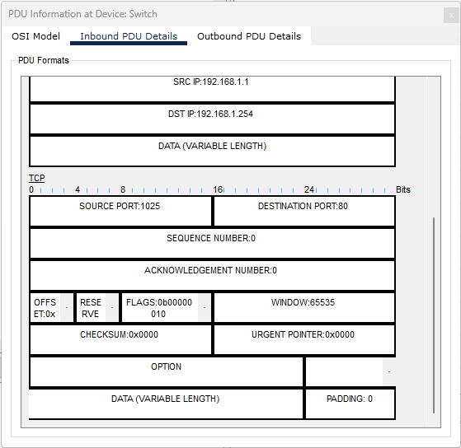  TCP
 | c2) | Yes. TCP is a reliable transport which has a connection oriented between sending and receiving process.

 | d) | DEST PORT: 80  SEQUENCE NUM: 0  SRC PORT: 1025  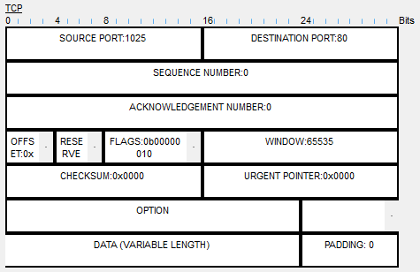  FLAGS = SYN  ACK NUM: 0
 | f) | DEST PORT: 1025 (reserved)  SEQUENCE NUM: 0 (unchanged)  SRC PORT: 80 (reserved)  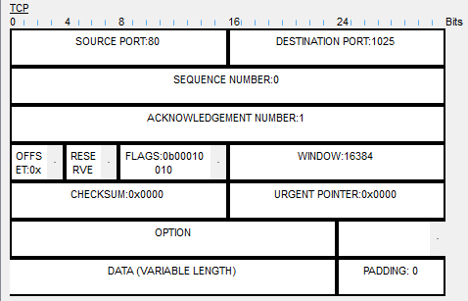  ACK NUM: 1 (changed)  FLAGS = SYN + ACK  SRC PORT and DEST PORT are reversed, ACK NUM changed to 1 and FLAGS changed to SYN + ACK

 | h) | DEST PORT: 80 (same as the first PDU)  SRC PORT: 1025 (same as the first PDU)  SEQUENCE NUM: 1 (changed)  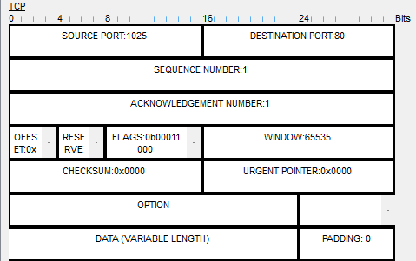  ACK NUM: 1 (unchanged)  FLAGS = PSH + ACK  SRC PORT and DEST PORT are reversed, SEQUENCE NUM and ACK NUM changed to 1, and FLAGS changed to PSH + ACK
Step3  [15m] | c1) | 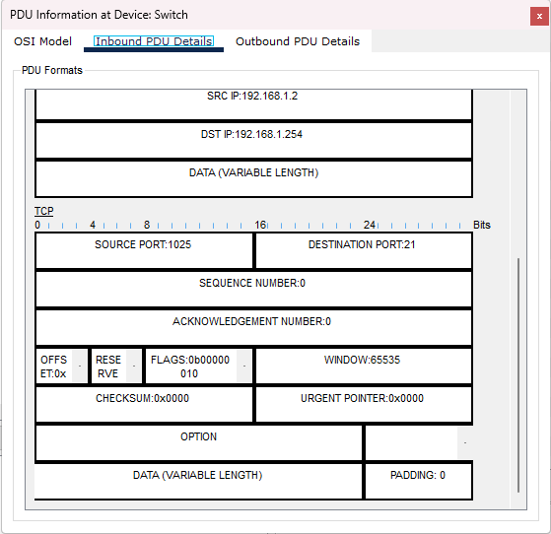  TCP
 | c2) | Yes. TCP is a reliable transport which has a connection oriented between sending and receiving process.
 | d) | SRC PORT: 1025  DEST PORT: 21  SEQUENCE NUM: 0  ACK NUM: 0  FLAGS = SYN  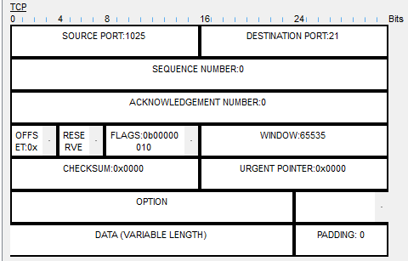
 | f) | SRC PORT: 21 (reserved)  DEST PORT: 1025 (reserved)  SEQUENCE NUM: 0 (unchanged)  FLAGS = SYN + ACK  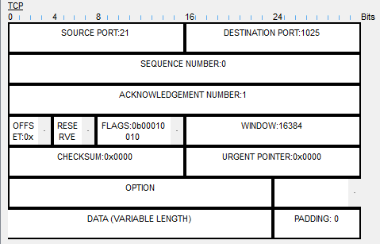  ACK NUM: 1 (changed)  SRC PORT and DEST PORT are reversed, ACK changed to 1 and FLAGS changed to SYN + ACK  SRC PORT: 1025  (same as the first PDU)  FLAGS = ACK  SEQUENCE NUM: 1 (changed)  DEST PORT: 21 (same as the frist PDU)
 | g) | 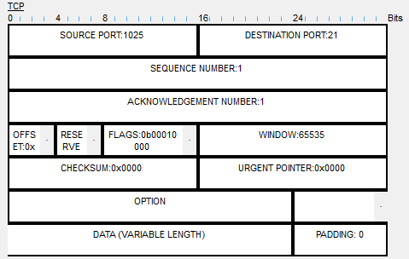  ACK NUM: 1 (unchanged)  SRC PORT and DEST PORT are reversed, SEQUENCE NUM and ACK NUM changed to 1, and FLAGS changed to ACK

 | i) | Message from the server: “Welcome to PT Ftp server”  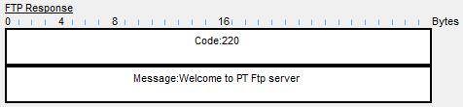

Step4  [15m] | c1) | 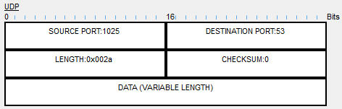  UDP
 | c2) | No. UDP is unreliable data transfer between sending and receiving process because it doesn’t have a connection oriented.
 | d) | DEST PORT: 53  SRC PORT: 1025    There is no SEQUENCE NUM and ACK NUM because UDP doesn’t need to establish a reliable connection.
 | f) | 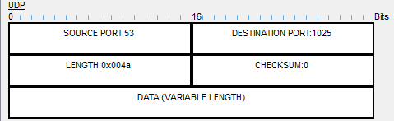  DEST PORT: 1025 (reversed)  SRC PORT: 53 (reversed)  There is not any SEQUENCE NUM and ACK NUM show in UDP connection.
 | g) | 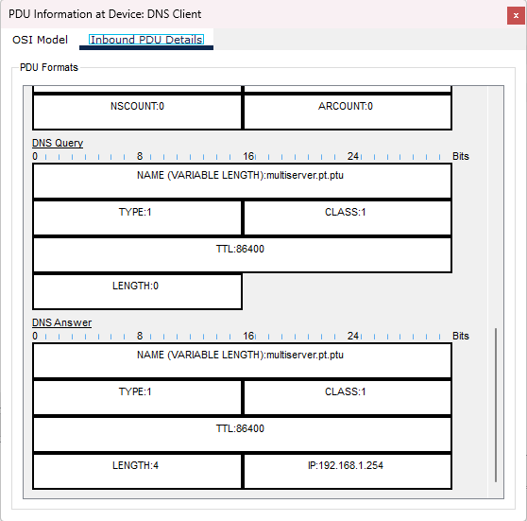  DNS Answer
Step5  [15m] | c1) | 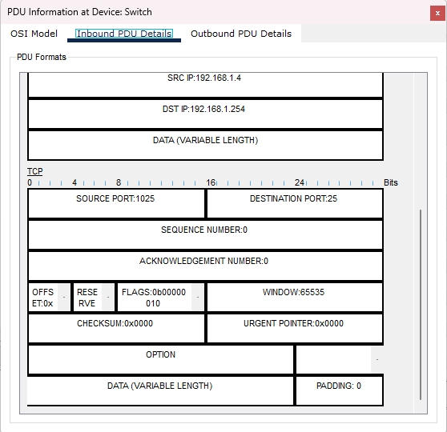  TCP
 | c2) | Yes. TCP is a reliable transport which has a connection oriented between sending and receiving process.
 | d) | FLAGS = SYN  ACK NUM: 0  SEQUENCE NUM: 0  DEST PORT: 25  SRC PORT: 1025  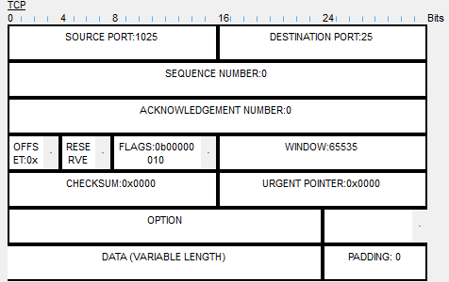
 | f) | SRC PORT: 25 (reserved)  DEST PORT: 1025 (reserved)  SEQUENCE NUM: 0 (unchanged)  FLAGS = SYN + ACK  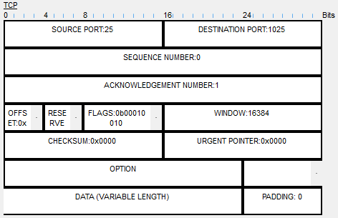  ACK NUM: 1 (changed)  SRC PORT and DEST PORT are reversed, ACK NUM changed to 1 and FLAGS changed to SYN + ACK  FLAGS = ACK  SEQUENCE NUM: 1 (different)  DEST PORT: 25 (same as the first PDU)  SRC PORT: 1025 (same as the first PDU)
 | g) | 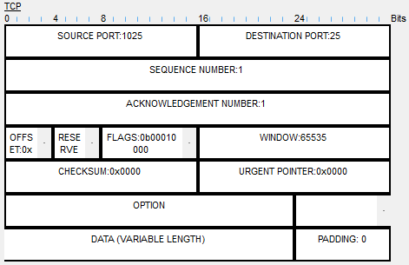  ACK NUM: 1 (unchanged)  SRC PORT and DEST PORT are reversed, SEQUENCE NUM and ACK NUM changed to 1, and FLAGS changed to ACK

 | i) | SRC PORT: 1025 (same as the first PDU)  DEST PORT: 25 (same as the first PDU)  SEQUENCE NUM: 1 (different)  FLAGS = PSH + ACK  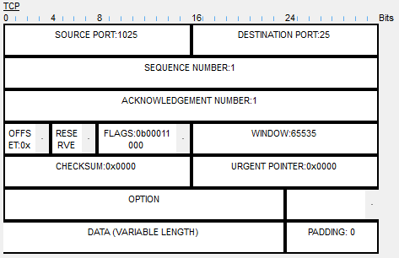  ACK NUM: 1 (unchanged)  SRC PORT and DEST PORT are reversed, SEQUENCE NUM and ACK NUM changed to 1, and FLAGS changed to PSH + ACK
 | j) | SMTP is associated with TCP port 25 and POP3 is associated with TCP port 110
Step6  [25m] | b1) | 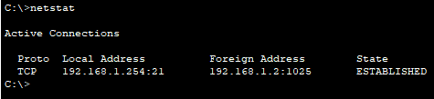  TCP
 | b2) |   Port 21
 | c) |   State: Established
 | d1) | 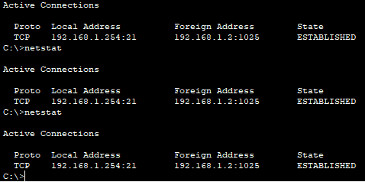  Port 21: FTP
 | d2) | 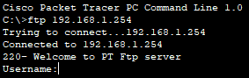  The server is waiting for the user input

